**Title:** AI Powered Mental Health Diagnosis System (Calmora)

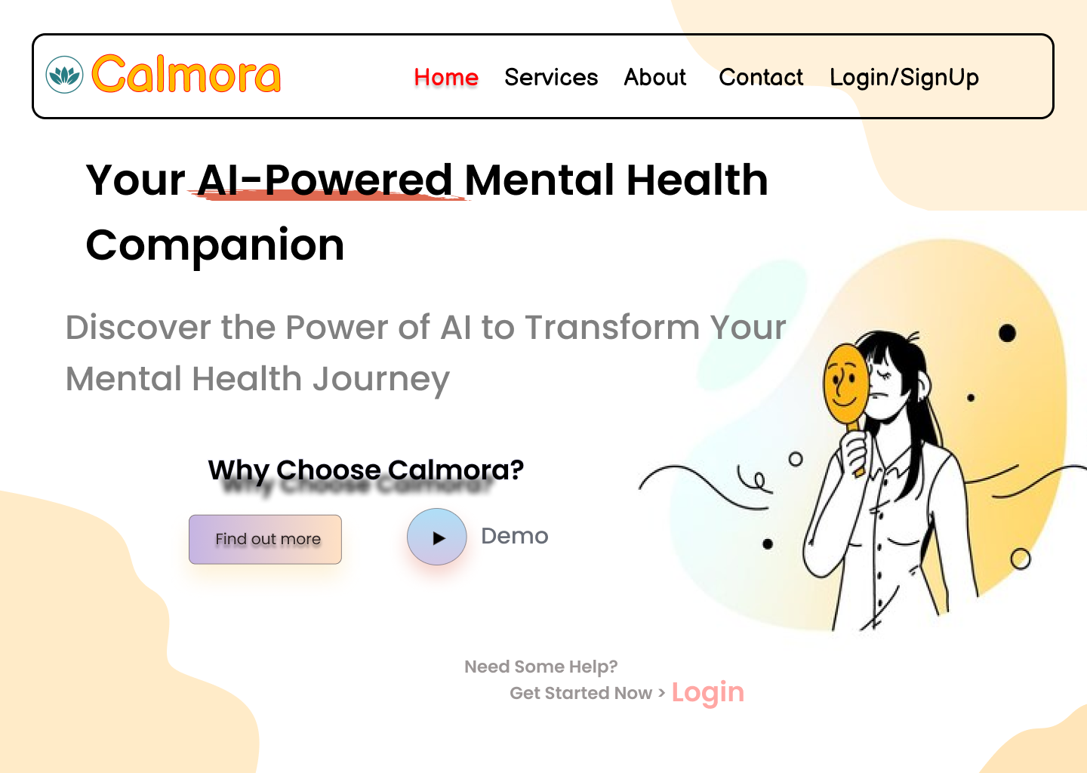

Landing Page

**1. Landing Page**

**Elements on the Page:**

1. **Navigation Bar**:
   * Home (redirects to the same page).
   * Services (redirects to the Services page).
   * About (redirects to the About page).
   * Contact (redirects to the Contact page).
   * Login/Signup (redirects to the Login/Signup page).
2. **Main Header**:
   * Title: *"Your AI-Powered Mental Health Companion."*
   * Subheading: *"Discover the Power of AI to Transform Your Mental Health Journey."*
3. **Buttons**:
   * **Demo**: Redirects the user to the chatbot in demo mode.
   * **Find Out More**: Redirects to the Services page.
4. **Visual Elements**:
   * Illustration of a user engaging with mental health support tools.
   * Calmora logo in the top-left corner.
5. **Footer Section**:
   * Links to Terms and Policies.
   * Subscription field for entering an email to receive updates and reminders.
   * Social media links (e.g., Facebook, Twitter, LinkedIn).

**Content of the Page:**

* A concise introduction to Calmora's purpose and features.
* Emphasis on AI-driven mental health tools.
* Encourages the user to explore or sign up for personalized recommendations.

**Data Flow:**

* **Subscription Form**: User enters their email, which is temporarily stored in a session and then saved in the database for notifications.
* **Button Clicks**: Redirect users to corresponding pages or features (e.g., Chatbot Demo, Services, or Login).

**Control Flow:**

1. **Before Interaction**:
   * Static content is displayed to the user.
   * Navigation links are clickable.
2. **After Interaction**:
   * Clicking *Demo* initiates a temporary session with the chatbot, storing basic user input.
   * Clicking *Find Out More* or navigation links redirects users to the respective pages.
   * Subscription adds the email to the notification list in the database.

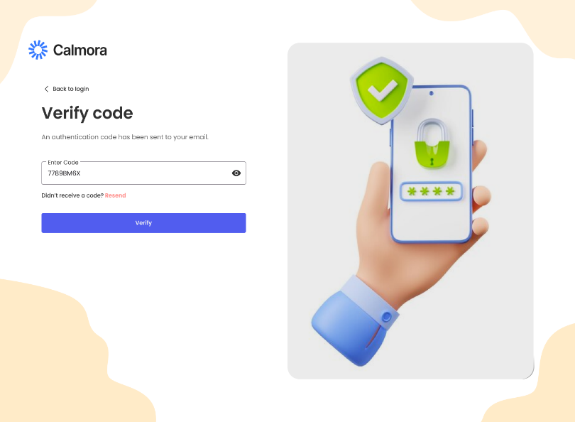

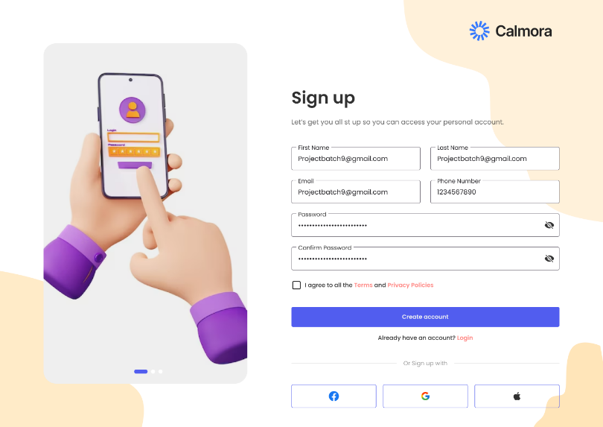

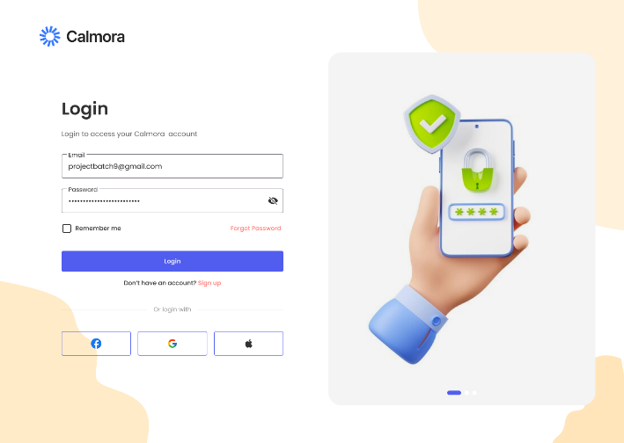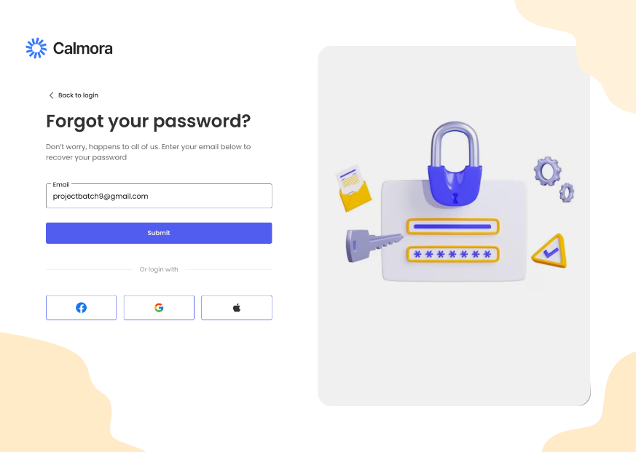

# 2. Login/Signup Page

**Page Name: Login/SignupElements on the Page:**

1. **Login Section**:
   * **Email Input Field**: For users to input their registered email.
   * **Password Input Field**: Masked field for entering a password.
   * **Remember Me Checkbox**: Option to keep the user logged in.
   * **Forgot Password Link**: Redirects to the password recovery flow.
   * **Login Button**: Validates the input and logs in the user.
   * **Social Login Buttons**:
     + Facebook, Google, and Apple icons for OAuth-based login.
2. **Signup Section**:
   * **Name Fields**: First Name and Last Name input boxes.
   * **Email Input Field**: For registering a new account.
   * **Phone Number Input Field**: Optional for two-factor authentication.
   * **Password Fields**:
     + Enter Password: Masked field.
     + Confirm Password: Masked field for re-entry to avoid mistakes.
   * **Terms and Privacy Checkbox**: User must agree before submitting.
   * **Signup Button**: Validates inputs and registers a new user.
   * **Redirect Link to Login**: Text like *"Already have an account? Login"*.
3. **Visual Elements**:
   * Calmora logo at the top.
   * A welcoming illustration representing security (e.g., shield and lock).
4. **Footer Section**:
   * Links to Terms and Conditions, Privacy Policy.
   * Contact Support link for login issues.

**Content of the Page:**

* Header: *"Login to Your Calmora Account"* or *"Create Your Calmora Account"*, depending on the tab selected.
* Subtext:
  + For Login: *"Access your personalized mental health tools."*
  + For Signup: *"Sign up to unlock tailored recommendations, assessments, and more."*

**Data Flow:**

1. **Login Process**:
   * User enters their email and password.
   * The system verifies the credentials against the database.
   * If correct, the user session is initialized, and they are redirected to the Dashboard.
   * If incorrect, an error message is displayed.
2. **Signup Process**:
   * User enters details (name, email, phone, password).
   * The system validates fields (e.g., email format, password match).
   * On success, the data is stored in the database, and a welcome email is triggered.
   * Redirects user to the Dashboard after login.
3. **Forgot Password**:
   * Redirects to a page where the user enters their email.
   * Sends a reset link or verification code for password recovery.
4. **OAuth Login**:
   * Initiates authentication through third-party APIs (Facebook, Google, Apple).
   * Fetches user details, creates a new account if not existing, or logs in directly.

**Control Flow:**

1. **Before Interaction**:
   * Displays the login form by default, with a toggle to the signup form.
   * Pre-fills fields if “Remember Me” was previously selected.
2. **After Interaction**:
   * Login Button: Validates credentials and redirects to the Dashboard or displays an error.
   * Signup Button: Validates input, stores the data, and redirects to the Dashboard.
   * Forgot Password: Redirects to the recovery flow.
   * Social Login: Connects to third-party OAuth services, processes tokens, and logs in.

# 3. Forgot Password Page

**Page Name: Forgot Password**

**Elements on the Page:**

**Header Section:**

1. **Title**:
   * *"Forgot Your Password?"*
2. **Description**:
   * *"No worries, we’ll help you reset it in a few steps."*

**Main Content Area:**

1. **Email Input Field**:
   * Placeholder: *"Enter your registered email address."*
   * Validation for correct email format (e.g., *@domain.com*).
2. **Submit Button**:
   * Text: *"Send Reset Link"*
   * Action: Sends a password reset link or verification code to the entered email.
3. **Instructional Text**:
   * Below the button: *"Check your email for a link to reset your password. It may take a few minutes."*
4. **Back to Login**:
   * Text link: *"Return to Login"*
   * Redirects back to the Login page.
5. **Error/Success Notifications**:
   * Error Message: *"Email not found. Please check your input."*
   * Success Message: *"Reset link sent to your email successfully."*

**Footer Section:**

* Links:
  + Terms of Service | Privacy Policy.

**Content of the Page:**

* **Header**: *"Reset Your Password Easily"*
* **Subheader**: *"Enter your registered email, and we’ll send you instructions to reset your password securely."*
* **Footer Note**: *"Need help? Contact Support."*

**Data Flow:**

1. **Input Submission**:
   * Email address is sent to the backend for verification.
2. **Validation**:
   * The system checks if the email exists in the database.
   * If valid, generates a secure reset token and sends it to the user's email.
3. **Response**:
   * Displays success or error message based on the verification outcome.

**Control Flow:**

1. **Before Interaction**:
   * The page displays a single input field for the email and a "Send Reset Link" button.
   * A user-friendly message encourages interaction.
2. **During Interaction**:
   * User submits their email.
   * The system validates the email against the database.
3. **After Interaction**:
   * Successful request displays a confirmation message and sends the reset link.
   * Failed request shows an error (e.g., *"Email not found."*).

# 4. Services Page

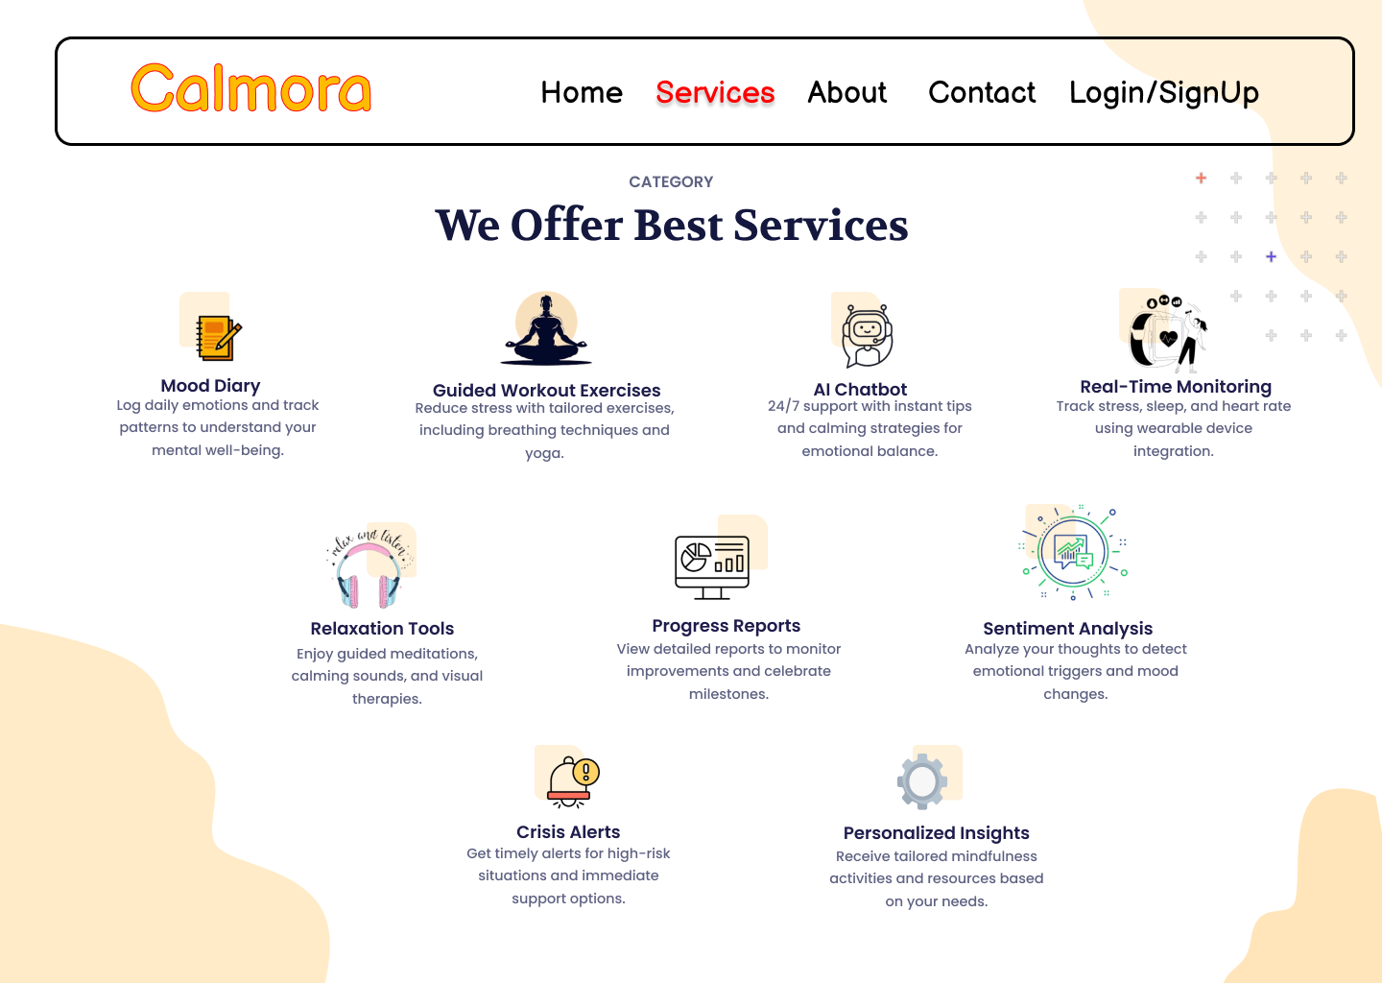

**Page Name: Services**

**Elements on the Page:**

1. **Header Section**:
   * Calmora logo.
   * Navigation Bar:
     + Links: *Home*, *Services*, *About*, *Contact*, *Login/Signup*.
     + Highlighted *Services* link for current page.
2. **Main Content Area**:
   * **Title**: *"We Offer Best Services"* (or similar welcoming heading).
   * **Service Cards**:
     + **Mood Diary**:
       - Icon: Notebook or journal symbol.
       - Description: *"Log daily emotions and track patterns to understand your mental well-being."*
     + **Guided Workout Exercises**:
       - Icon: Meditation or yoga pose.
       - Description: *"Reduce stress with tailored exercises, including breathing techniques and yoga."*
     + **AI Chatbot**:
       - Icon: Chatbot illustration.
       - Description: *"24/7 support with instant tips and calming strategies for emotional balance."*
     + **Real-Time Monitoring**:
       - Icon: Wearable device icon.
       - Description: *"Track stress, sleep, and heart rate using wearable device integration."*
     + **Relaxation Tools**:
       - Icon: Headphones with calming sound waves.
       - Description: *"Enjoy guided meditations, calming sounds, and visual therapies."*
     + **Progress Reports**:
       - Icon: Graph symbol.
       - Description: *"View detailed reports to monitor improvements and celebrate milestones."*
     + **Sentiment Analysis**:
       - Icon: Analytics chart.
       - Description: *"Analyze your thoughts to detect emotional triggers and mood changes."*
     + **Crisis Alerts**:
       - Icon: Alert symbol.
       - Description: *"Get timely alerts for high-risk situations and immediate support options."*
     + **Personalized Insights**:
       - Icon: Gear or recommendation symbol.
       - Description: *"Receive tailored mindfulness activities and resources based on your needs."*
3. **Call-to-Action (CTA)**:
   * Text: *"Sign up or log in to explore these services in detail!"*
   * Button: *"Login/Signup"* (Redirects to authentication page).
4. **Footer Section**:
   * Terms and Conditions link.
   * Privacy Policy link.
   * Contact Us link.

**Content of the Page:**

* Header: *"Explore Calmora's Comprehensive Mental Health Services"*
* Subtext: *"Designed to empower your mental well-being journey with cutting-edge AI solutions."*
* Each Service Card includes:
  + Icon.
  + Short description.
  + Encourages users to *sign up* for more.

**Data Flow:**

1. **Static Content**:
   * All service descriptions and icons are static and fetched from the front-end code.
   * No dynamic or user-specific data at this stage.
2. **Redirects**:
   * Links/buttons redirect users to the Login/Signup page to access service details.

**Control Flow:**

1. **Before Interaction**:
   * Displays all services with brief descriptions.
   * All interaction options (buttons/links) are visible but prompt user to log in.
2. **After Interaction**:
   * Clicking on any service card or the CTA button redirects users to the Login/Signup page.

# 5. About Page

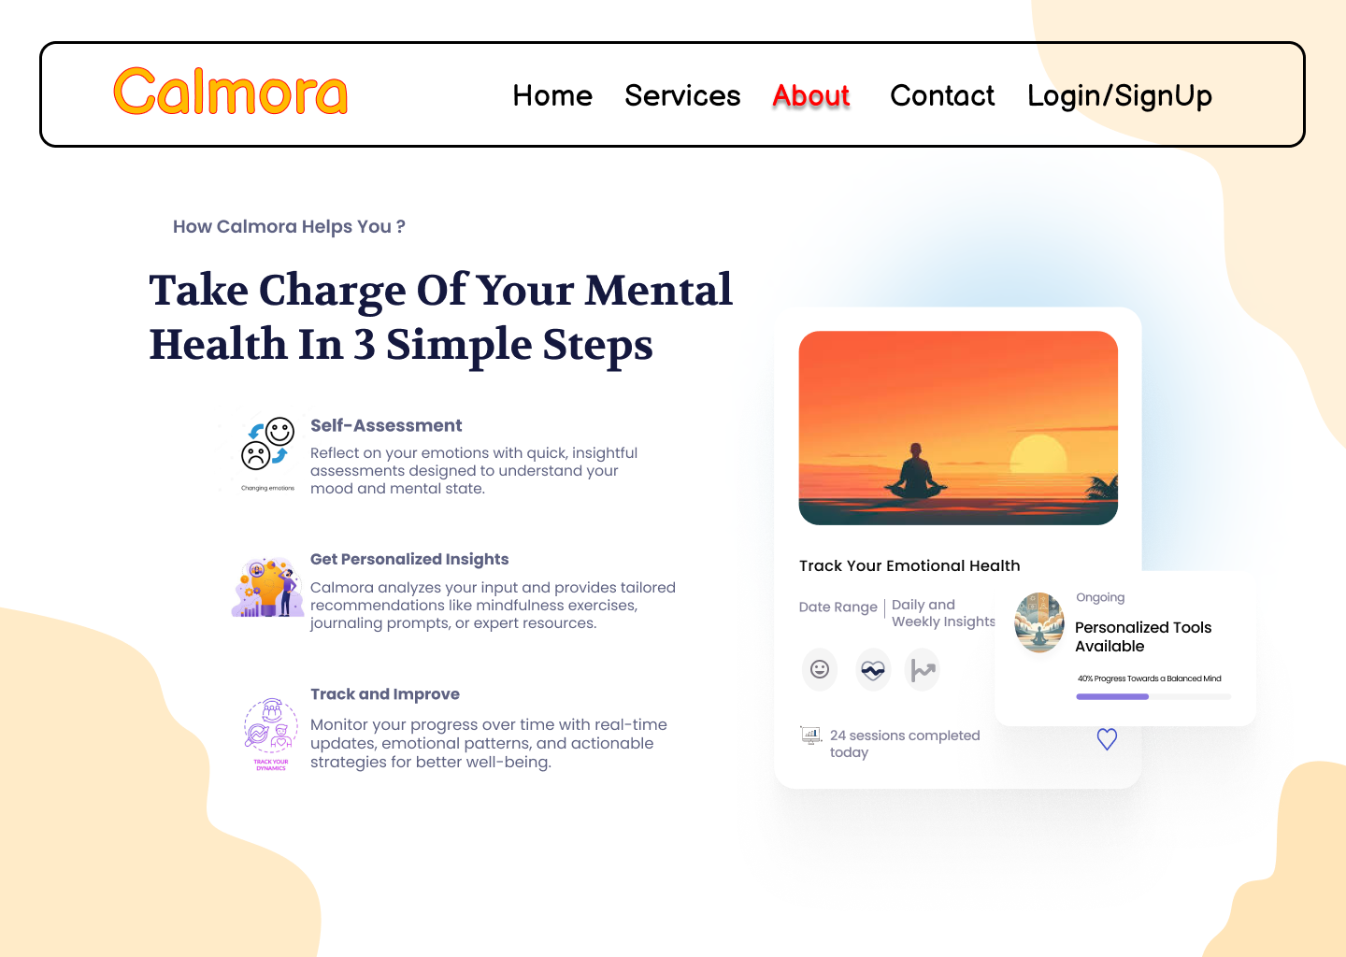

**Elements on the Page:**

1. **Header Section**:
   * Calmora logo.
   * Navigation Bar:
     + Links: *Home*, *Services*, *About*, *Contact*, *Login/Signup*.
     + Highlighted *About* link for current page.
2. **Main Content Area**:
   * **Title**: *"Discover Calmora"* or *"About Calmora"*
   * **Description**:
     + Text explaining Calmora's mission and vision.
     + Focus on the platform's core goals: *Empowering mental health through AI-powered solutions*.
   * **Key Features Overview**:
     + Short descriptions of Calmora's standout features:
       - AI-powered insights.
       - Personalized recommendations.
       - Real-time monitoring.
       - Secure and user-friendly design.
   * **Calmora's Journey Section**:
     + Timeline or story-like text explaining Calmora’s inception, growth, and the problem it aims to solve.
   * **Core Values**:
     + Cards or bulleted points listing Calmora's core values like *Innovation, Inclusivity, Privacy, Empowerment*.
3. **Team Highlights (Optional)**:
   * Section showing key contributors or the visionaries behind Calmora.
   * Placeholder images with brief bios (e.g., Founder/Guide details).
4. **Call-to-Action (CTA)**:
   * Text: *"Join us in making mental health accessible to all."*
   * Button: *"Sign Up Now"* (Redirects to the Login/Signup page).
5. **Footer Section**:
   * Links to Terms, Privacy Policy, and Contact Us.

**Content of the Page:**

* **Mission Statement**: *"Our mission is to enhance mental well-being through accessible, AI-driven solutions for everyone, everywhere."*
* **Vision Statement**: *"To create a world where mental health support is just a click away, empowering individuals to lead balanced and fulfilling lives."*
* **Why Choose Calmora?**:
  + AI-powered personalized insights.
  + Real-time monitoring for proactive interventions.
  + User-friendly design accessible to all.
* **Tagline**: *"Your Peace, Powered by AI."*

**Data Flow:**

1. **Static Content**:
   * All information about Calmora (mission, vision, team, etc.) is static and pre-coded into the front-end.
2. **Dynamic Redirects**:
   * Buttons or links redirect users to the Login/Signup page to access Calmora’s services in detail.

**Control Flow:**

1. **Before Interaction**:
   * Static text and images present Calmora's story and features.
   * Navigation links guide users to relevant sections of the page.
2. **After Interaction**:
   * Clicking on the CTA button (e.g., *Sign Up Now*) or navigation links like *Services* redirects users to the respective pages.

# **6. Contact Page**

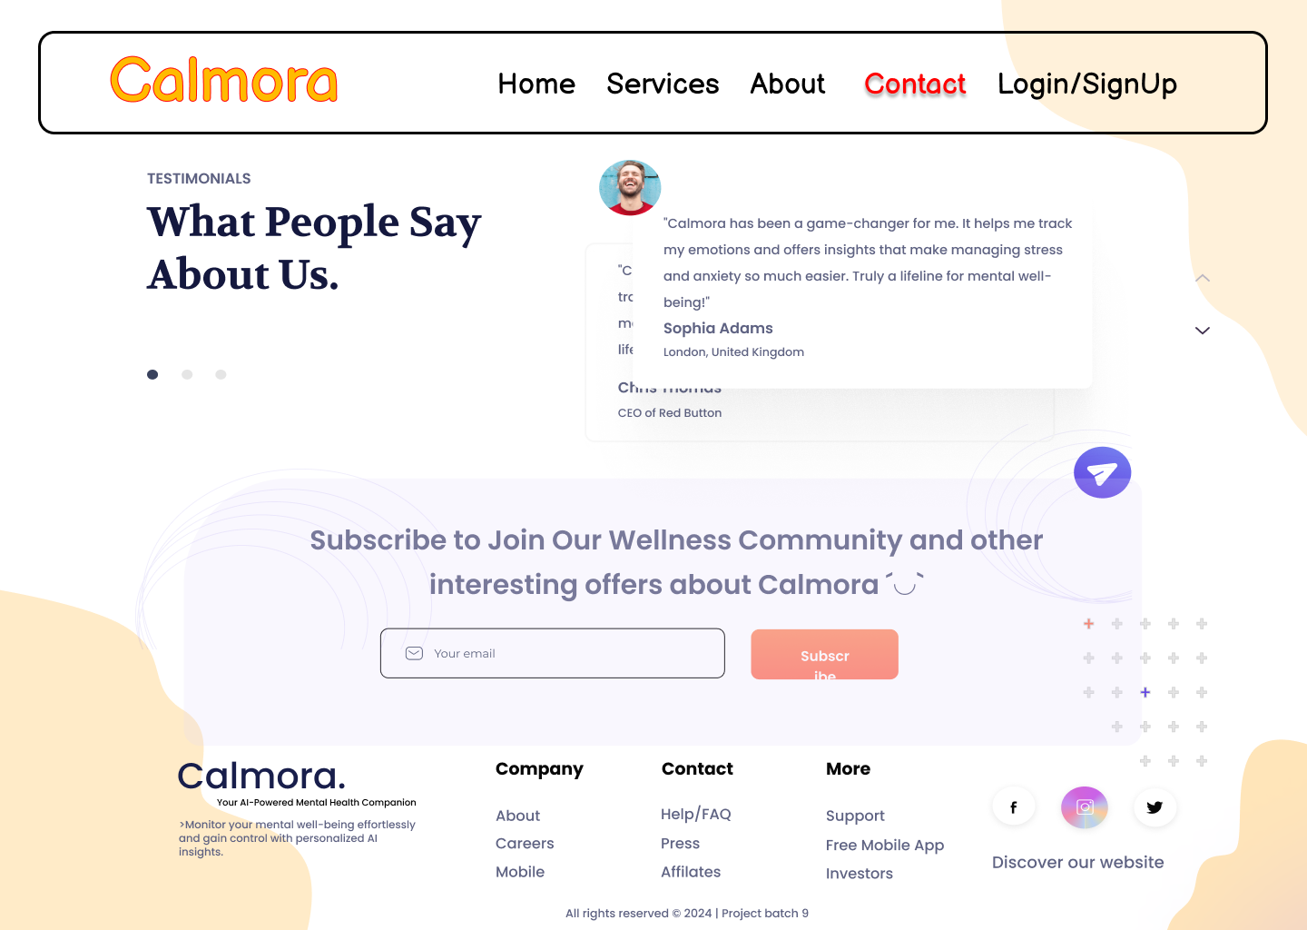

**Page Name: Contact**

**Elements on the Page:**

1. **Header Section**:
   * Calmora logo.
   * Navigation Bar:
     + Links: *Home*, *Services*, *About*, *Contact*, *Login/Signup*.
     + Highlighted *Contact* link for the current page.
2. **Main Content Area**:
   * **Title**: *"Get in Touch with Us"*
   * **Description**:
     + Brief message encouraging users to reach out for support or inquiries.
     + Example text: *"We’re here to help! Contact us for any assistance, questions, or feedback."*
   * **Contact Form**:
     + Fields:
       - Name (input field)
       - Email Address (input field)
       - Message (textarea)
     + Submit Button: *"Send Message"* (Non-functional in pre-login mode, redirects to *Login/Signup* page).
3. **Subscription Feature**:
   * Text: *"Stay updated with the latest from Calmora!"*
   * Email input field for newsletter subscription.
   * Subscribe Button: *"Subscribe"* (Stores user email in a temporary session for post-login notifications).
4. **Address Section (Optional)**:
   * Placeholder for Calmora’s contact address or headquarters.
   * Example: *"123 Innovation Lane, Tech City, USA."*
5. **Social Media Links**:
   * Icons with links to Calmora’s social media platforms (e.g., Facebook, Twitter, LinkedIn, Instagram).
   * Example icons with hover effects.
6. **Footer Section**:
   * Links to Terms & Conditions, Privacy Policy, and Login/Signup.

**Content of the Page:**

* **Welcome Message**:
  + *"We’d Love to Hear from You!"*
* **Contact Form Instructions**:
  + *"Fill out the form below, and we’ll get back to you shortly."*
* **Placeholder Text for Fields**:
  + Name: *"Enter your name"*
  + Email: *"Enter your email address"*
  + Message: *"Write your message here…"*

**Data Flow:**

1. **Static Content**:
   * Contact details and placeholders for form fields are pre-coded.
   * Social media links redirect users to external platforms.
2. **Temporary Session Data**:
   * If a user subscribes, their email address is stored temporarily and prompts them to log in/sign up for continued updates.

**Control Flow:**

1. **Before Interaction**:
   * Users see the contact form, subscription section, and social media links.
   * Placeholder text encourages user input.
2. **After Interaction**:
   * Clicking *"Send Message"* redirects to the *Login/Signup* page.
   * Subscribing stores the user’s email for future reminders to log in/sign up.

**Subscription/Notifications**

**Elements on the Page:**

**Header Section:**

1. **Title**:
   * *"Stay Connected with Calmora"*
2. **Description**:
   * *"Receive updates, reminders, and tips straight to your inbox."*

**Main Content Area:**

1. **Subscription Form**:
   * **Email Input Field**:
     + Placeholder: *"Enter your email address."*
   * **Subscribe Button**:
     + Text: *"Subscribe Now"*
     + Action: Stores the entered email and adds it to the mailing list.
   * **Confirmation Text**:
     + Appears after successful subscription: *"Thank you for subscribing! Check your inbox for updates."*
   * **Error Handling**:
     + If invalid email: *"Please enter a valid email address."*
2. **Subscription Benefits Section**:
   * Icons with descriptions:
     + **Daily Mood Reminders**: *"Never miss a day to track your mood."*
     + **Wellness Tips**: *"Get mental health tips and techniques."*
     + **Feature Updates**: *"Stay informed about new features and services."*
3. **Footer Section**:
   * Links to Terms of Service, Privacy Policy, and Login/Signup page.
   * Calmora branding: *"Your Peace, Powered by AI."*

**Content of the Page:**

* **Welcome Text**:
  + *"Join thousands of Calmora users in staying updated and proactive about mental health."*
* **CTA Section**:
  + Encourages users to sign up for notifications: *"Subscribe now to take charge of your mental well-being."*

**Data Flow:**

1. **Subscription Input**:
   * User enters their email.
   * Data is validated for proper format (e.g., *@domain.com*).
2. **Data Storage**:
   * Valid emails are stored in the database for notifications.
3. **Confirmation**:
   * A welcome email or confirmation message is sent to the subscribed address.

**Control Flow:**

1. **Before Interaction**:
   * The page displays a subscription form with fields and a description of benefits.
   * Placeholders guide the user to input their email.
2. **During Interaction**:
   * User submits the form.
   * Backend validates the email and stores it if valid.
3. **After Interaction**:
   * Success: Confirmation message appears, and a welcome email is sent.
   * Failure: An error message prompts the user to correct the input.

# 7. Chatbot (Demo Mode) Page

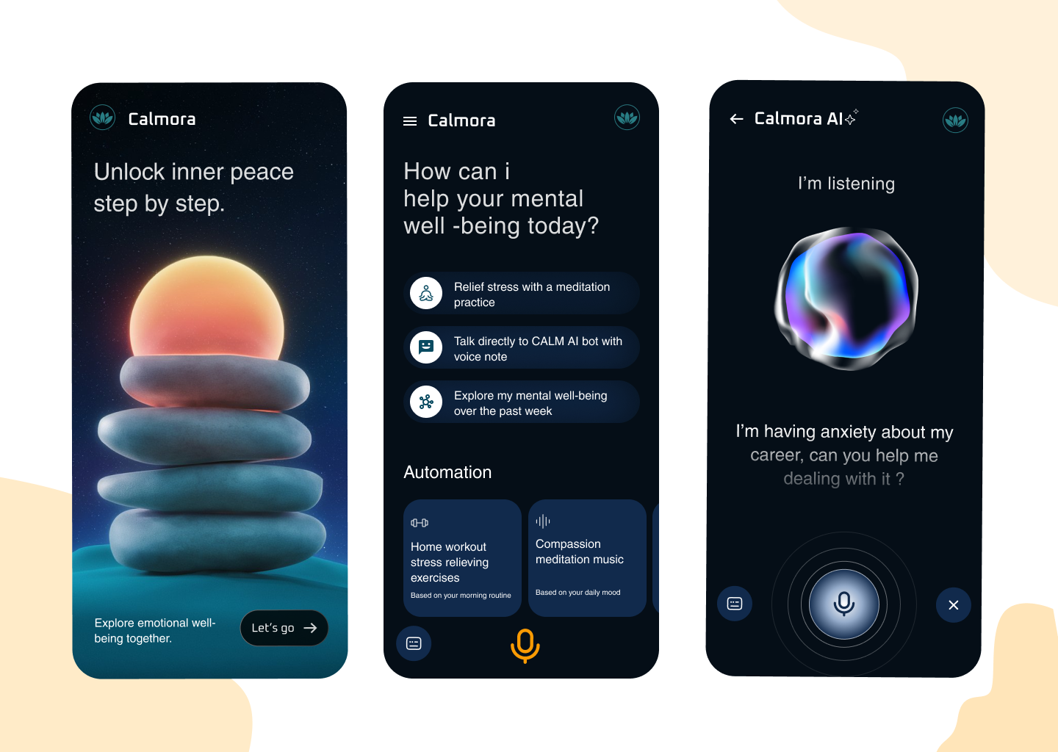

**Page Name: Chatbot (Demo Mode)**

**Elements on the Page:**

**Header Section:**

1. **Title**:
   * *"Experience the Calmora Chatbot"*
2. **Description**:
   * *"Discover how our AI-powered chatbot helps with mental well-being."*

**Main Content Area:**

1. **Chat Window**:
   * **Input Field**:
     + Placeholder: *"Type your message here…"*
   * **Send Button**:
     + Icon: Send arrow icon.
     + Action: Sends the typed message for AI response.
   * **Chat Display Area**:
     + Displays a back-and-forth conversation between the user and the chatbot.
     + Sample responses:
       - *"Hello! How are you feeling today?"*
       - *"Based on your mood, here are a few tips to stay calm."*
   * **Static Recommendations**:
     + Generic responses suggesting services like:
       - *"Try our Mood Diary to log your emotions."*
       - *"Explore Guided Workouts for relaxation."*
2. **CTA Button**:
   * Text: *"Sign Up to Unlock Full Features"*
   * Action: Redirects to the Login/Signup page.

**Footer Section:**

* Links:
  + Home | Services | About | Login/Signup.
* Note: *"This is a demo. Log in for a personalized experience."*

**Content of the Page:**

* **Welcome Message**:
  + Chatbot: *"Hi! I’m your Calmora assistant. Let’s take a step towards mental well-being together."*
* **Sample Chat Examples**:
  + User: *"I feel stressed."*
  + Chatbot: *"Stress is tough. Would you like to try breathing exercises or guided meditation?"*

**Data Flow:**

1. **Input Handling**:
   * User inputs text into the chat window.
   * Input is processed and stored in a temporary session (demo-only mode).
2. **AI Response**:
   * The AI generates a response based on pre-loaded generic patterns (no user-specific data is analyzed in demo mode).
3. **Recommendations**:
   * Links to services are displayed based on user inputs.

**Control Flow:**

1. **Before Interaction**:
   * Static text and chatbot interface are loaded.
   * User can type messages to the chatbot.
2. **During Interaction**:
   * User sends input.
   * Chatbot processes the input and responds based on pre-defined logic.
   * Responses include links or CTAs directing the user to sign up for full functionality.
3. **After Interaction**:
   * If the user clicks on a CTA or service link, they are redirected to the Login/Signup page.

# After Login

# 1. Dashboard Page

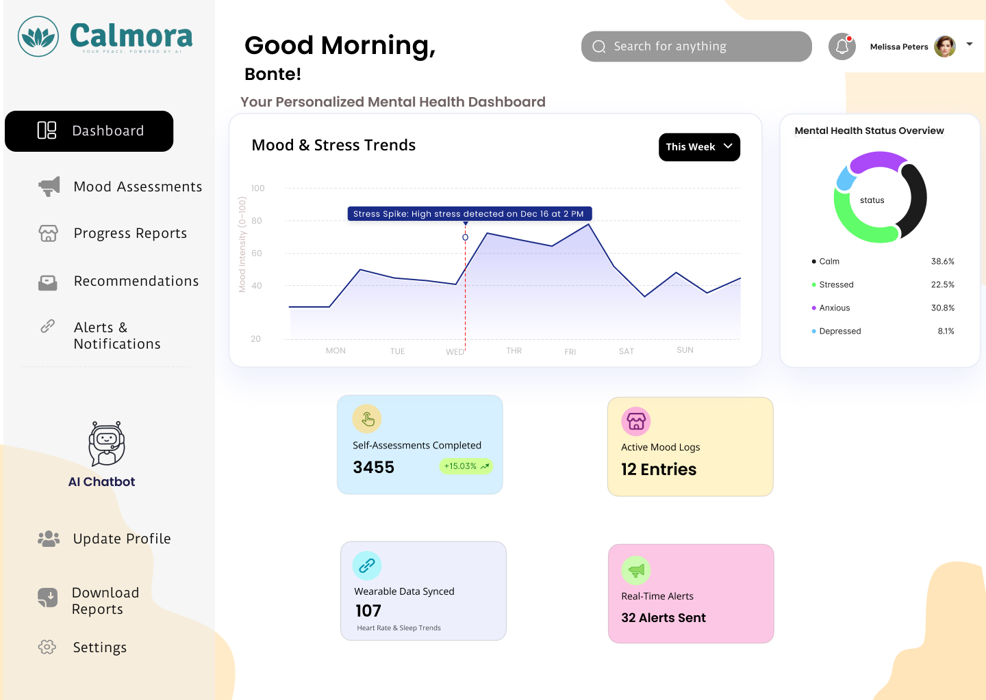

**Page Name: Dashboard**

**Elements on the Page:**

**Header Section:**

1. **Title**:
   * *"Welcome Back, [User Name]!"*
2. **User Profile**:
   * Profile picture/icon with options to view or edit profile.

**Main Content Area:**

1. **Quick Stats Overview**:
   * Mood Summary:
     + Icon: Smiley faces indicating the user’s current mood trend (e.g., happy, neutral, sad).
     + Text: *"Your current mood: [Mood]"*.
   * Weekly Mood Trend Chart:
     + Visual line graph or bar chart showing mood fluctuations over the past week.
   * Stress Level Indicator:
     + Gauge or bar showing stress levels, e.g., *"Moderate"*.
2. **Daily Tasks/Reminders**:
   * List of activities for the day (e.g., *"Complete your mood assessment," "Try today’s meditation session."*).
   * Checkboxes to mark tasks as complete.
3. **Recent Activities**:
   * A timeline or log of the user’s recent interactions with the platform (e.g., *"Logged mood on Dec 27," "Completed guided breathing exercise."*).
4. **CTA Buttons**:
   * **Log Mood**: Redirects to the Mood Diary page.
   * **Start Activity**: Redirects to Recommendations or Guided Workout Exercises.

**Footer Section:**

* Quick Navigation Links:
  + Mood Diary | Assessments | Reports | Settings.

**Content of the Page:**

* **Welcome Message**:
  + Example: *"Hello, [User Name]! Let’s make today a good day for your mental health."*
* **Encouraging Text**:
  + Example: *"Small steps lead to big changes. Start your wellness journey now!"*

**Data Flow:**

1. **Mood Data Retrieval**:
   * Fetches the user’s past mood entries from the database to display trends.
2. **Activity Recommendations**:
   * Pulls data from the AI engine to generate daily suggestions based on user patterns.
3. **Task Completion Updates**:
   * Marks tasks as complete and updates the database.
4. **Stress Level Calculation**:
   * Analyzes mood and wearable data (if connected) to update stress indicators.

**Control Flow:**

1. **Before Interaction**:
   * Displays the user’s personalized dashboard with pre-fetched data.
   * All buttons and links are visible and actionable.
2. **During Interaction**:
   * User clicks to log mood, start activities, or view detailed trends.
   * System dynamically loads the respective pages or features.
3. **After Interaction**:
   * Updates dashboard elements (e.g., marking tasks as completed or refreshing mood trends) in real time.

# 2.0 Mood Assessments Page

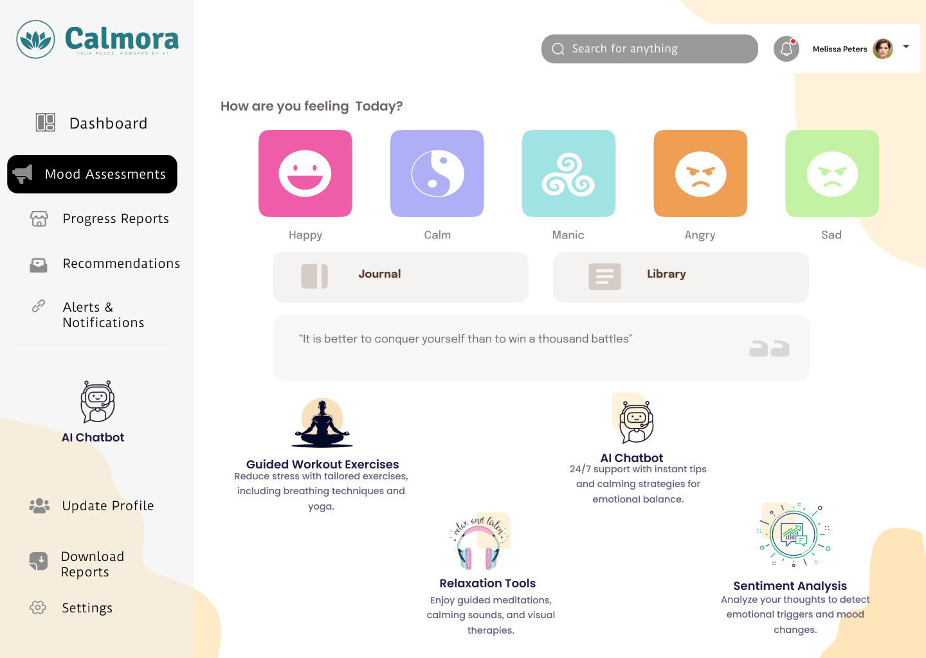

**Page Name: Mood Assessments**

**Elements on the Page:**

**Header Section:**

1. **Title**:
   * *"Track Your Mood, Take Charge of Your Day!"*
2. **User Greeting**:
   * Example: *"Hi, [User Name]! Let’s assess how you’re feeling today."*

**Main Content Area:**

1. **Mood Assessment Interface**:
   * **Mood Scale**:
     + Slider or emoji-based options (e.g., Very Happy 😊 → Neutral 😐 → Very Sad 😢).
     + Prompt: *"How are you feeling right now?"*
     + ***If possible include the features when we clicked on emojis it have to navigate to corresponding pages or it has to redirects to bot after login and takes input and process the input***
   * **Custom Tags**:
     + Text field or buttons to tag specific feelings (e.g., *"Anxious," "Excited," "Tired."*).
     + Auto-suggestions for common tags.
   * **Mood Triggers**:
     + Dropdown or checkbox list to indicate potential triggers (e.g., *"Work stress," "Family time," "Health concerns."*).
2. **Optional Questions Section**:
   * Follow-up prompts:
     + *"What’s contributing to this mood?"*
     + *"Any specific activities that helped or worsened it?"*
   * Open text field for detailed entries.
3. **CTA Button**:
   * Text: *"Save Mood Entry"*
   * Action: Stores the mood assessment in the database.
4. **Previous Assessments Summary**:
   * Small section displaying the user’s last mood entries with timestamps:
     + Example: *"Dec 28: Happy 😊, Feeling accomplished after work."*

**Footer Section:**

* Quick Navigation:
  + Links to Dashboard | Recommendations | Mood Diary.

**Content of the Page:**

* **Prompt Text**:
  + *"Understanding your mood is the first step to a better day."*
* **Encouraging Quote**:
  + Example: *"Your emotions are valid, and every mood matters."*

**Data Flow:**

1. **Mood Data Entry**:
   * User inputs mood rating, tags, triggers, and optional comments.
   * Data is sent to the backend for analysis and storage.
2. **AI Analysis**:
   * Analyzes the mood entry for patterns or emotional trends.
   * Updates the database with real-time insights.
3. **Recommendations Engine**:
   * Uses new mood data to adjust recommendations on the Dashboard and Recommendations page.

**Control Flow:**

1. **Before Interaction**:
   * Displays the mood scale, triggers, and optional fields for the current assessment.
   * Loads recent mood entries for reference.
2. **During Interaction**:
   * User interacts with the slider, inputs tags, and answers optional prompts.
   * Data is validated (e.g., no empty mandatory fields).
3. **After Interaction**:
   * Mood entry is saved.
   * Confirmation message appears (e.g., *"Mood successfully logged!"*).
   * Dashboard and Recommendations are dynamically updated based on new insights.

# 2.1 Guided Workout Exercises Page

**Page Name: Guided Workout Exercises**

**Elements on the Page:**

**Header Section:**

1. **Title**:
   * *"Feel Better, One Move at a Time!"*
2. **User Greeting**:
   * Example: *"Hi, [User Name]! Let’s get moving for your well-being."*

**Main Content Area:**

1. **Workout Categories**:
   * **Yoga**:
     + Poses with video demonstrations (e.g., Child’s Pose, Downward Dog).
     + Timer for holding each pose.
   * **Breathing Exercises**:
     + Techniques like *Box Breathing* and *Alternate Nostril Breathing*.
     + Visual guides to sync breathing.
   * **Stretching Routines**:
     + Targeted stretches for stress relief (e.g., neck, shoulder, back stretches).
     + Audio guidance for ease of use.
2. **Achievements Tracker**:
   * Visual progress bar tracking completed sets, total time spent, and calories burned.
   * Example: *"You’ve completed 5 yoga sessions this week!"*
3. **CTA Buttons**:
   * **Start Session**: Launches a guided session with step-by-step instructions.
   * **Log Completion**: Updates user progress in the database.
4. **Recommendations Section**:
   * Suggested routines based on recent mood assessments.

**Footer Section:**

* Quick Navigation:
  + Links to Mood Assessments | Meditation | Dashboard.

**Content of the Page:**

* **Motivational Text**:
  + Example: *"Every stretch and breath counts towards a calmer you."*
* **Tips Section**:
  + Quick advice like *"Focus on slow, deep breaths for maximum relaxation."*

**Data Flow:**

1. **Workout Progress Tracking**:
   * Logs completed exercises and time spent in the database.
2. **Personalized Suggestions**:
   * Updates exercise recommendations based on mood and stress data.
3. **AI Feedback**:
   * Analyzes exercise logs to suggest adjustments for better results.

**Control Flow:**

1. **Before Interaction**:
   * Displays available exercises with descriptions.
   * Tracks and shows user progress.
2. **During Interaction**:
   * User starts a session or logs a completed workout.
   * Timer or audio guidance runs during the session.
3. **After Interaction**:
   * Progress data is saved.
   * New recommendations are generated for upcoming sessions.

# 2.2Meditation Page

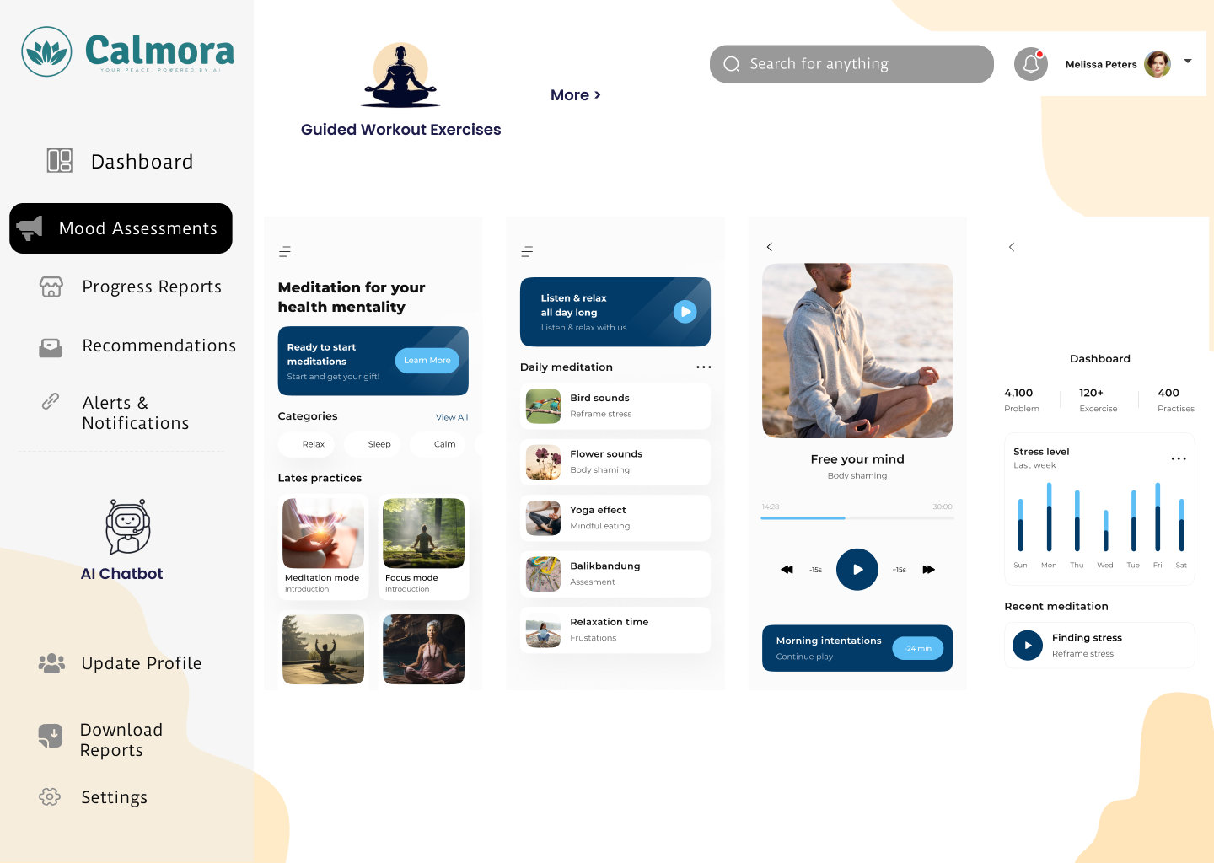

**Page Name: Meditation**

**Elements on the Page:**

**Header Section:**

1. **Title**:
   * *"Breathe, Relax, and Unwind"*
2. **User Greeting**:
   * Example: *"Hi, [User Name]! Let’s take a moment for yourself."*

**Main Content Area:**

1. **Meditation Categories**:
   * **Guided Meditations**:
     + Themes include *Stress Relief*, *Sleep Aid*, *Focus Boost*, and *Gratitude Practice*.
     + Audio or video sessions with durations like 5, 10, and 20 minutes.
   * **Ambient Sounds**:
     + Calming options such as *Rainfall*, *Ocean Waves*, *Forest Breeze*.
     + Option to combine sounds for a personalized ambiance.
   * **Mindfulness Practices**:
     + Exercises like *Body Scan* and *Mindful Breathing*.
     + Text or audio guidance to lead the session.
2. **Session Tracker**:
   * Logs completed sessions with time spent.
   * Example: *"You’ve meditated for 20 minutes today!"*
3. **Mood Integration**:
   * Suggests meditation sessions based on recent mood entries:
     + Example: *"Feeling anxious? Try a 10-minute stress relief meditation."*
4. **CTA Buttons**:
   * **Start Session**: Launches the selected meditation session.
   * **Log Completion**: Updates user progress in the database.

**Footer Section:**

* Quick Navigation:
  + Links to Guided Workout Exercises | Relaxing Tools | Dashboard.

**Content of the Page:**

* **Encouraging Text**:
  + Example: *"A few mindful moments can make a world of difference."*
* **Tips Section**:
  + Quick advice like *"Focus on your breathing and let go of distractions."*

**Data Flow:**

1. **Meditation Session Tracking**:
   * Logs completed sessions, time spent, and type of meditation.
2. **Personalized Recommendations**:
   * Updates suggested meditations based on mood and session history.
3. **AI Feedback**:
   * Analyzes session data to suggest improvements or adjustments.

**Control Flow:**

1. **Before Interaction**:
   * Displays available meditation options with descriptions.
   * Tracks and shows user progress.
2. **During Interaction**:
   * User starts a session and follows audio or visual guidance.
   * Timer runs during the session, displaying progress.
3. **After Interaction**:
   * Progress is logged.
   * Recommendations are updated based on session outcomes.

# 2.3 Relaxing Tools Page

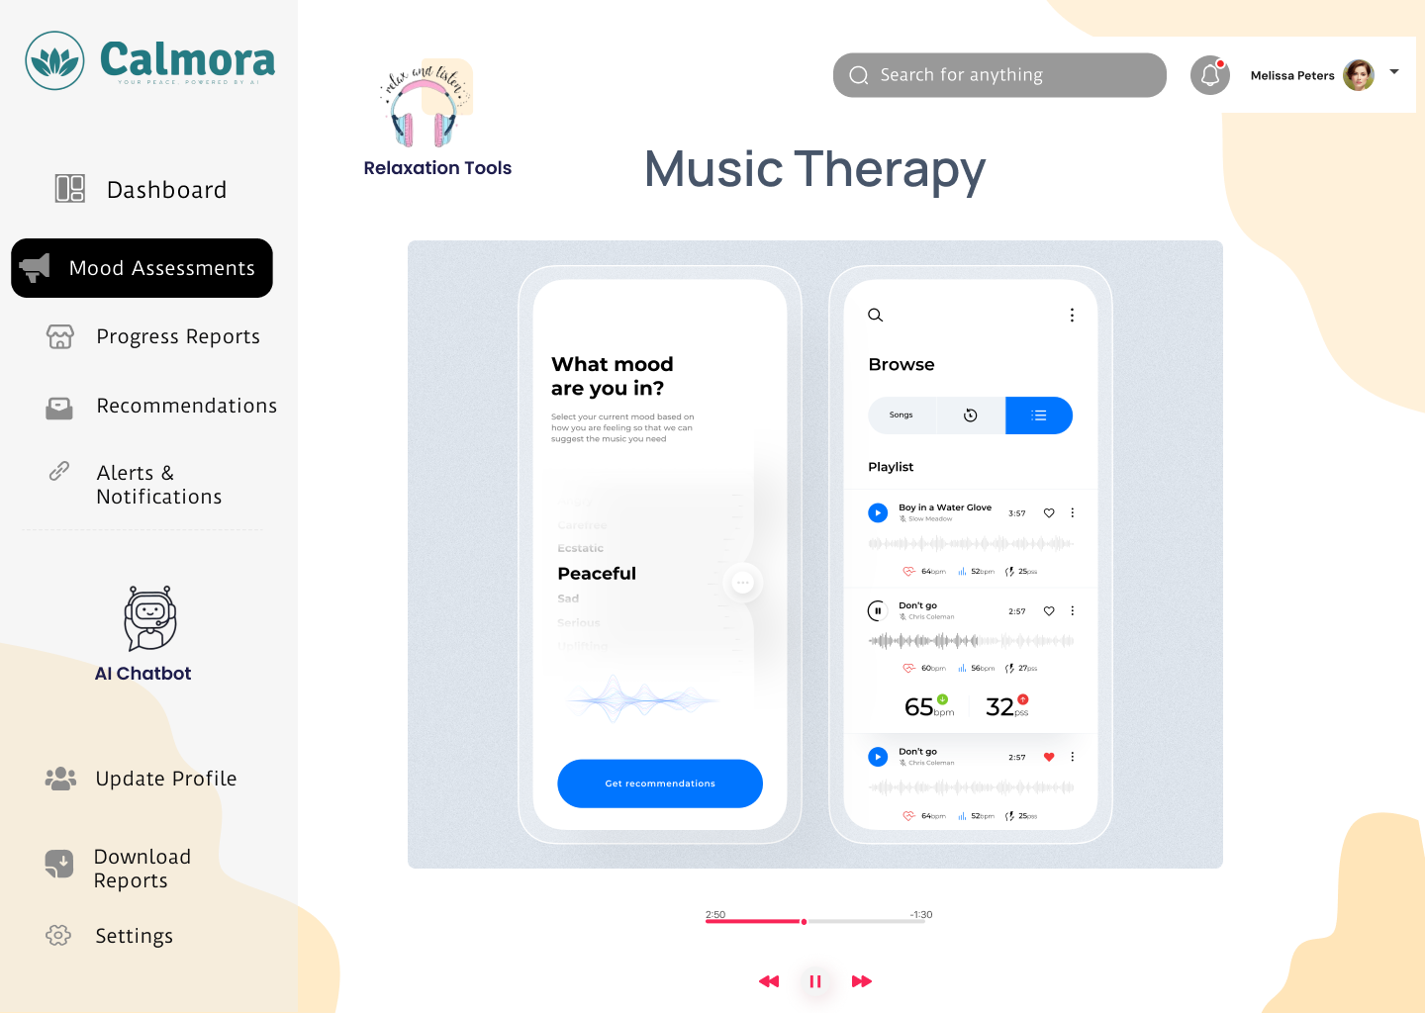

**Page Name: Relaxing Tools**

**Elements on the Page:**

**Header Section:**

1. **Title**:
   * *"Discover Your Calm Zone"*
2. **User Greeting**:
   * Example: *"Hi, [User Name]! Let’s find what relaxes you the most."*

**Main Content Area:**

1. **Tool Categories**:
   * **Calming Sounds**:
     + Preloaded tracks such as *Rainfall*, *Crackling Fire*, *Wind Chimes*, and *Ocean Waves*.
     + Playback controls (Play, Pause, Volume Adjustment).
   * **Visual Relaxation**:
     + Soothing visualizations such as *Floating Clouds*, *Rippling Water*, and *Soft Candlelight*.
     + Option for fullscreen mode.
   * **Interactive Stress Relief**:
     + Features like *Digital Sand Art* or *Bubble Popping Game* for interactive relaxation.
   * **Breathing Assistance**:
     + Guided visual or audio exercises to regulate breathing patterns.
     + Prompts like *"Inhale for 4 seconds, hold for 4 seconds, exhale for 6 seconds."*
2. **Session Tracker**:
   * Logs time spent on each relaxation activity.
   * Example: *"You’ve used Relaxing Tools for 15 minutes today."*
3. **Mood Suggestions**:
   * Recommends tools based on recent mood entries:
     + Example: *"Feeling overwhelmed? Try calming ocean sounds or visualizations."*
4. **CTA Buttons**:
   * **Start Session**: Begins the selected relaxation activity.
   * **Log Completion**: Saves the session details to the database.

**Footer Section:**

* Quick Navigation:
  + Links to Meditation | Dashboard | Guided Workout Exercises.

**Content of the Page:**

* **Encouraging Text**:
  + Example: *"Relaxation is just a click away. Let’s find your calm."*
* **Tips Section**:
  + Quick advice like *"Pick what resonates with you—sounds, visuals, or movement."*

**Data Flow:**

1. **Tool Usage Tracking**:
   * Logs selected tools, time spent, and user preferences in the database.
2. **Recommendations**:
   * Updates tool suggestions based on session history and mood data.
3. **AI Feedback**:
   * Analyzes tool usage trends to provide insights or encourage consistency.

**Control Flow:**

1. **Before Interaction**:
   * Displays available relaxation tools with a short description.
   * Shows previously used tools for quick access.
2. **During Interaction**:
   * User starts an activity and interacts with the chosen tool.
   * Timer tracks session duration.
3. **After Interaction**:
   * Session details are saved.
   * Dashboard and Recommendations pages are updated with new data.

# 2.4 MORE(Your wish bro include some small exercise if u have any)

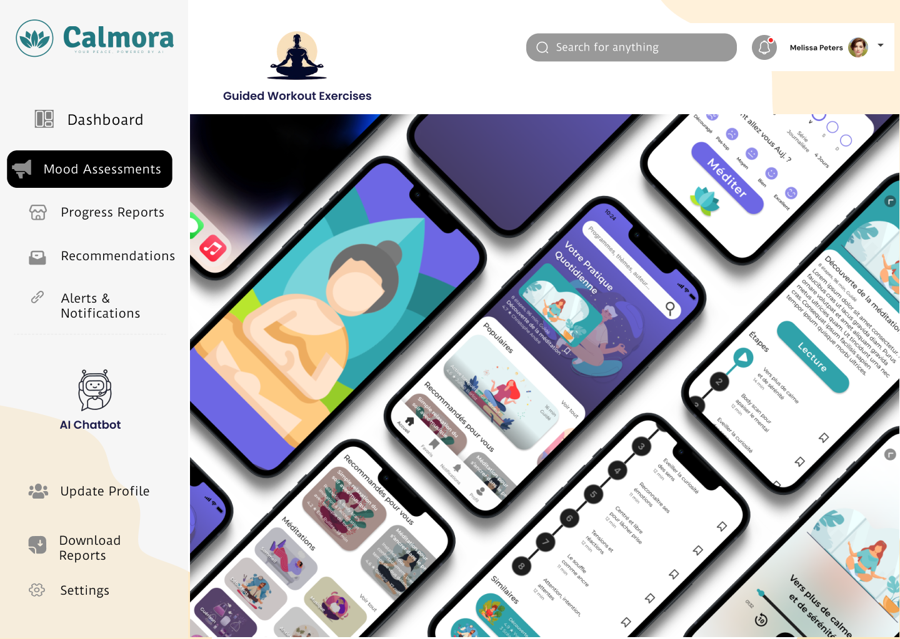

My suggestions:  
**More Page**

**Page Name: More**

**Elements on the Page:**

**Header Section:**

1. **Title**:
   * *"Explore More Features with Calmora"*
2. **Description**:
   * *"Discover additional tools and resources to enhance your well-being."*

**Main Content Area:**

1. **Additional Features**:
   * **Journaling**:
     + Prompts and templates for reflective journaling.
     + Sections like *Daily Gratitude*, *Achievements of the Day*, and *Emotional Thoughts*.
   * **Sleep Tracker**:
     + Integration with wearables to monitor sleep patterns.
     + Graphical insights on sleep quality, duration, and trends.
   * **Nutrition Recommendations**:
     + AI-based suggestions for mood-boosting foods.
     + Personalized meal ideas based on user inputs.
   * **Mental Health Blogs**:
     + Articles on topics like stress management, mindfulness, and emotional resilience.
     + Option to bookmark or share articles.
   * **Community Support**:
     + Access to forums or groups where users can share experiences and tips.
     + Moderated discussions to ensure a positive environment.
2. **CTA Buttons**:
   * **Explore**: Opens the respective feature (e.g., Journaling, Sleep Tracker).
   * **Get Started**: Redirects to pages like Settings for wearable integration or external resources.
3. **Personalized Suggestions**:
   * Recommends specific features based on recent activity and mood trends.
   * Example: *"Feeling stressed? Try reflective journaling to organize your thoughts."*

**Footer Section:**

* Quick Navigation:
  + Links to Dashboard | Settings | Relaxing Tools.

**Content of the Page:**

* **Encouraging Text**:
  + Example: *"Your journey to well-being is filled with possibilities—let’s explore them."*
* **Tips Section**:
  + Advice on making the most of these features, like *"Use the sleep tracker for better rest insights."*

**Data Flow:**

1. **Feature Access**:
   * Logs which features the user interacts with (e.g., Journaling, Sleep Tracker).
2. **Wearable Integration**:
   * Pulls data from connected devices for features like Sleep Tracker or Nutrition Recommendations.
3. **AI Feedback**:
   * Updates personalized suggestions based on usage trends and recent activities.

**Control Flow:**

1. **Before Interaction**:
   * Displays available features with descriptions and action buttons.
   * Highlights recommended features for the user.
2. **During Interaction**:
   * User clicks on a feature (e.g., Journaling) and navigates to its dedicated page.
   * If integration is required (e.g., Sleep Tracker), guides the user through setup steps.
3. **After Interaction**:
   * Logs activity data and updates personalized recommendations for future sessions.

# 3. Progress Reports Page

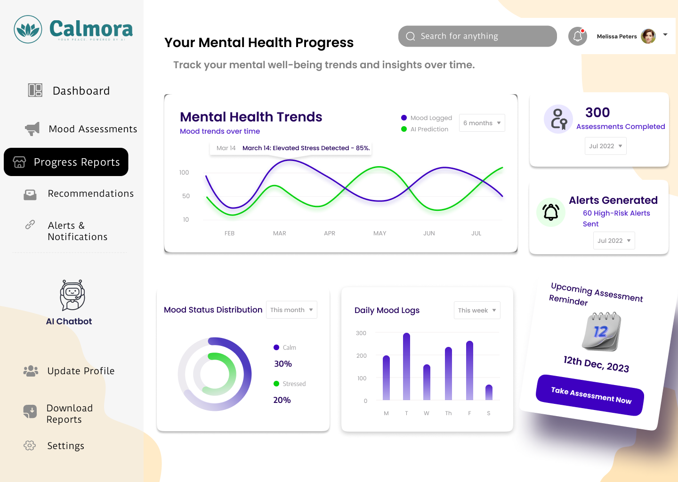

**Page Name: Progress Reports**

**Elements on the Page:**

**Header Section:**

1. **Title**:
   * *"Track Your Progress Over Time"*
2. **User Greeting**:
   * Example: *"Hi, [User Name]! Here’s a summary of your mental health journey."*

**Main Content Area:**

1. **Graphical Reports**:
   * **Mood Trends**:
     + A line graph or bar chart showing daily or weekly mood fluctuations.
     + Axis labels:
       - X-Axis: Dates.
       - Y-Axis: Mood ratings (e.g., Happy, Neutral, Sad).
   * **Stress Distribution**:
     + Pie chart showing proportions of stress levels over a selected period (e.g., *High, Medium, Low*).
   * **Activity Log**:
     + List or table of completed activities (e.g., Mood Assessments, Meditations, Guided Workouts).
2. **Filters**:
   * Dropdown menus or buttons for:
     + **Date Range**: Options like *Last Week*, *Last Month*, *Custom Range*.
     + **Metrics to View**: Mood, Stress, Sleep, Activities.
   * Example: *"View your mood trends for the past month."*
3. **Key Insights Section**:
   * Summarized text based on AI analysis:
     + Example: *"You were happiest during weekends and stressed on Mondays."*
     + Suggestions to improve patterns, like *"Try meditation on high-stress days."*
4. **CTA Buttons**:
   * **Download Report**:
     + Downloads a detailed PDF of all progress reports.
   * **Share Insights**:
     + Generates a shareable link or email summary (optional).

**Footer Section:**

* Quick Navigation:
  + Links to Dashboard | Mood Diary | Recommendations.

**Content of the Page:**

* **Header Text**:
  + *"Your Well-Being at a Glance"*
* **Encouraging Text**:
  + Example: *"Every step counts—track your progress to see how far you’ve come."*

**Data Flow:**

1. **Graph Data Retrieval**:
   * Pulls historical mood, stress, and activity data from the database.
2. **Insights Generation**:
   * AI analyzes data trends and generates personalized insights.
3. **Export Functionality**:
   * Compiles data into a downloadable PDF format for the user.

**Control Flow:**

1. **Before Interaction**:
   * Displays default reports (e.g., Last Week’s Mood Trends).
   * Filters and graphs are pre-loaded with existing data.
2. **During Interaction**:
   * User selects filters or clicks buttons to view specific metrics or date ranges.
   * Graphs and insights dynamically update in real time.
3. **After Interaction**:
   * Reports are downloaded or shared based on user action.
   * Dashboard and Recommendations pages are updated with new insights.

# 4.0 Recommendations Page

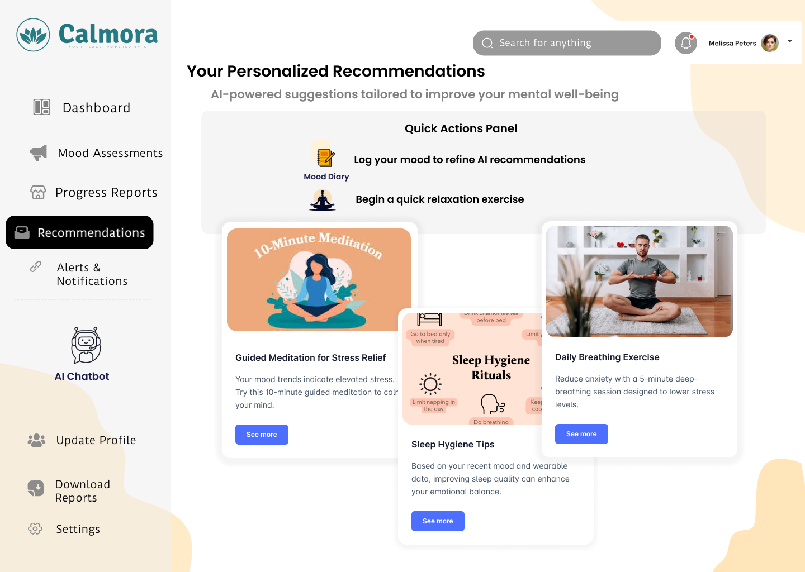

**Page Name: Recommendations**

**Elements on the Page:**

**Header Section:**

1. **Title**:
   * *"Personalized Recommendations for Your Well-Being"*
2. **User Greeting**:
   * Example: *"Hi, [User Name]! Here’s what we recommend for you today."*

**Main Content Area:**

1. **Daily Recommendations**:
   * A list of suggested activities based on the user’s recent mood assessments and activity logs:
     + Example:
       - *"Try a 10-minute breathing exercise for relaxation."*
       - *"Explore our guided gratitude meditation session."*
2. **Category-Based Suggestions**:
   * **Mental Health**:
     + AI-powered tools like mood tracking or cognitive behavioral exercises.
   * **Physical Health**:
     + Activities like yoga, stretching, or workouts to improve emotional balance.
   * **Mindfulness**:
     + Recommendations for meditations, relaxing tools, or calming sounds.
   * **Social Activities**:
     + Suggestions for connecting with supportive communities or forums.
3. **CTA Buttons**:
   * **Start Now**:
     + Initiates the recommended activity (e.g., launches the meditation or workout session).
   * **Learn More**:
     + Redirects to a detailed description of the activity or feature.
4. **Past Recommendations**:
   * A history log of previously completed recommendations:
     + Example: *"On Dec 27, you completed a gratitude journaling session."*

**Footer Section:**

* Quick Navigation:
  + Links to Dashboard | Progress Reports | Mood Diary.

**Content of the Page:**

* **Encouraging Text**:
  + Example: *"Your mental health journey is unique—here’s what we think can help today."*
* **Tips Section**:
  + Advice like *"Pick activities that resonate with your current mood for the best results."*

**Data Flow:**

1. **Recommendation Engine**:
   * AI processes the user’s mood, activity logs, and stress data to generate personalized suggestions.
2. **Activity Feedback**:
   * Tracks user engagement with recommended activities and adjusts future recommendations.
3. **Integration with Other Pages**:
   * Connects recommendations with guided workouts, meditations, and mood assessments for seamless navigation.

**Control Flow:**

1. **Before Interaction**:
   * Displays default recommendations based on pre-analyzed user data.
   * Lists CTAs like *"Start Now"* or *"Learn More"* for each suggestion.
2. **During Interaction**:
   * User clicks on a recommendation to initiate the activity.
   * The system dynamically updates the recommendation status to *"In Progress"*.
3. **After Interaction**:
   * Completed activities are logged in the database.
   * Future recommendations are updated based on the user’s progress.

# 4.1 Mood Diary

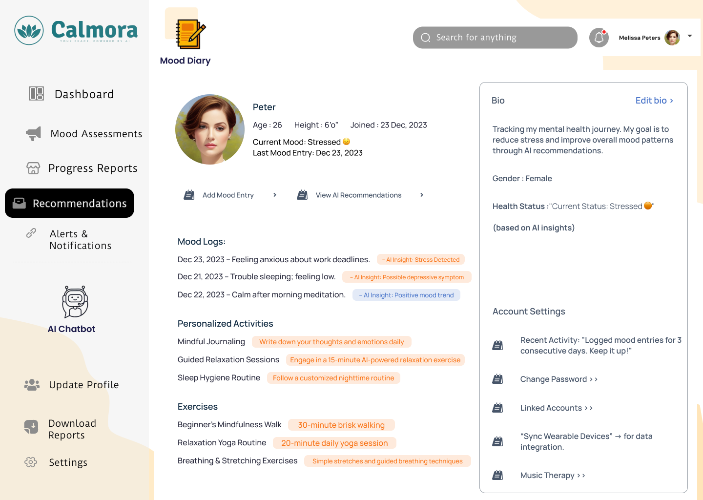

**Page Name: Mood Diary**

**Elements on the Page:**

**Header Section:**

1. **Title**:
   * *"Reflect and Log Your Daily Emotions"*
2. **User Greeting**:
   * Example: *"Hi, [User Name]! Let’s record how you’re feeling today."*

**Main Content Area:**

1. **Diary Entry Interface**:
   * **Mood Selection**:
     + Slider or emoji-based options (Very Happy 😊 → Neutral 😐 → Very Sad 😢).
     + Prompt: *"How are you feeling today?"*
   * **Mood Triggers**:
     + Drop-down menu or checkbox list for mood triggers (e.g., *Work*, *Relationships*, *Health*).
   * **Recommendation Integration**:
     + Pre-populated suggestions from the **Recommendations Page** based on user activity.
       - Example: *"Did you complete the gratitude journaling recommendation? If yes, describe its impact."*
   * **Open-Ended Text Field**:
     + Free text input for users to reflect on their day.
     + Placeholder: *"Describe your day in a few words…"*
2. **Entry History**:
   * Displays past diary entries with timestamps.
   * Example:
     + *"Dec 27: Feeling productive after completing yoga."*
3. **CTA Buttons**:
   * **Save Entry**:
     + Stores the current diary entry in the database.
   * **View Trends**:
     + Redirects to the **Progress Reports Page**.

**Footer Section:**

* Quick Navigation:
  + Links to Dashboard | Recommendations | Progress Reports.

**Content of the Page:**

* **Encouraging Text**:
  + Example: *"Your thoughts and feelings are important—let’s reflect together."*
* **Tips Section**:
  + Example: *"Be honest with yourself—every emotion is valid and part of your journey."*

**Data Flow:**

1. **Input Collection**:
   * User inputs mood, triggers, and reflections.
   * Pre-filled prompts are pulled from the **Recommendations Page**.
2. **Data Storage**:
   * Entry data is stored in the database with timestamps for future analysis.
3. **Integration with Other Pages**:
   * Updates the **Progress Reports Page** with new mood trends.
   * Provides feedback to the **Recommendations Page** to improve personalization.

**Control Flow:**

1. **Before Interaction**:
   * Displays the diary entry interface with pre-populated prompts from recommendations.
   * Shows past diary entries for reference.
2. **During Interaction**:
   * User completes mood selection, adds triggers, and writes reflections.
   * Prompts encourage users to link activities or recommendations to their diary entries.
3. **After Interaction**:
   * The diary entry is saved and reflected in the **Progress Reports Page**.
   * Future recommendations adjust based on the mood and activity impact described in the diary.

# 5.Alerts & Notifications Page

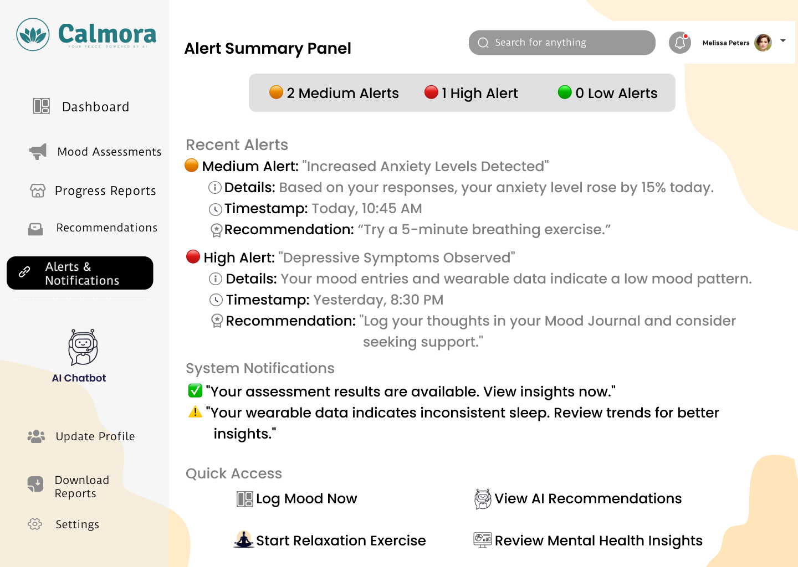

**Page Name: Alerts & Notifications**

**Elements on the Page:**

**Header Section:**

1. **Title**:
   * *"Stay Informed and On Track"*
2. **User Greeting**:
   * Example: *"Hi, [User Name]! Here’s what you need to know today."*

**Main Content Area:**

1. **Real-Time Alerts**:
   * **High-Stress Detection**:
     + AI-generated alerts based on mood trends and wearable data or activities data.
     + Example: *"Your stress levels are high. Consider trying a relaxation tool."*
   * **Activity Reminders**:
     + Notifications for pending tasks (e.g., *"Don’t forget to complete your mood assessment today!"*).
2. **Upcoming Activities**:
   * A calendar-like interface displaying scheduled activities or reminders.
     + Example: *"Guided meditation session at 6 PM."*
3. **Past Notifications Log**:
   * A history section showing previous notifications and their statuses (e.g., *Acknowledged, Dismissed*).
     + Example:
       - *"Dec 27: Try gratitude journaling to manage your stress levels."*
       - *"Dec 26: AI detected improved mood after yoga session."*
4. **Notification Preferences**:
   * Toggle options to customize what notifications the user wants to receive:
     + **Mood Assessment Reminders**
     + **Activity Completion Notifications**
     + **Progress Updates**
     + **Stress or Mood Alerts**
5. **CTA Buttons**:
   * **Take Action**:
     + Redirects to the relevant page (e.g., Relaxing Tools, Mood Assessments).
   * **Mark as Done**:
     + Clears the notification and updates the status in the database.

**Footer Section:**

* Quick Navigation:
  + Links to Dashboard | Recommendations | Settings.

**Content of the Page:**

* **Encouraging Text**:
  + Example: *"Timely reminders to keep you on track and stress-free."*
* **Tips Section**:
  + Example: *"Customizing notifications can make them more effective for your goals."*

**Data Flow:**

1. **Alert Generation**:
   * AI processes user data (mood trends, activity logs, wearable data) to generate alerts.
2. **Notification Delivery**:
   * Push notifications or email alerts are sent based on user preferences.
3. **Interaction Logging**:
   * User actions (e.g., marking notifications as done) are saved in the database.

**Control Flow:**

1. **Before Interaction**:
   * Displays active alerts and reminders in priority order.
   * Allows users to view a history of past notifications.
2. **During Interaction**:
   * User acknowledges or takes action on notifications.
   * Preferences for notification types can be customized.
3. **After Interaction**:
   * Completed tasks or dismissed alerts are marked as resolved.
   * AI updates future notification strategies based on user interaction patterns.

# 6. Settings Page

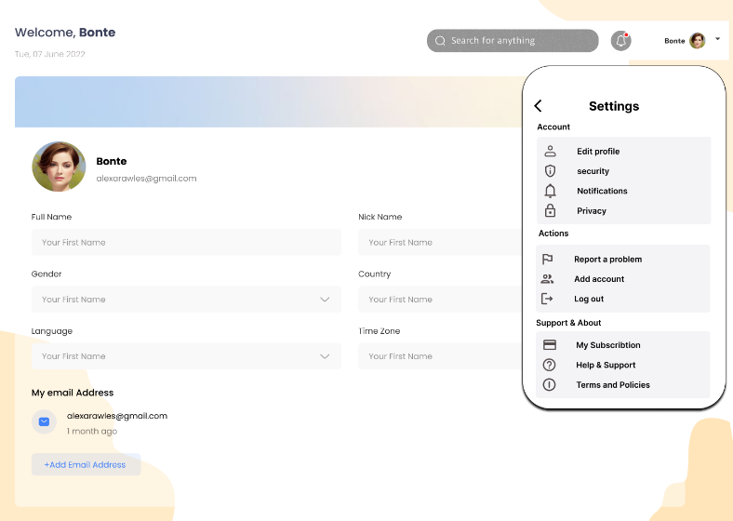

**Page Name: Settings**

**Elements on the Page:**

**Header Section:**

1. **Title**:
   * *"Manage Your Account and Preferences"*
2. **User Greeting**:
   * Example: *"Hi, [User Name]! Customize your Calmora experience."*

**Main Content Area:**

1. **Account Settings**:
   * **Edit Profile**:
     + Fields for Name, Email, and Profile Picture.
     + Button: *"Save Changes"*.
   * **Change Password**:
     + Current Password Field.
     + New Password and Confirm Password Fields.
     + Button: *"Update Password"*.
   * **Add Accounts**:
     + Integration options for third-party logins (Google, Facebook, Apple).
2. **Notification Preferences**:
   * Toggle switches for:
     + Mood Assessment Reminders.
     + Activity Completion Alerts.
     + Weekly Progress Reports.
     + Real-Time Stress Notifications.
3. **Privacy and Security Settings**:
   * **Data Privacy**:
     + Button: *"Download My Data"* (Provides user data as a downloadable file).
     + Button: *"Delete My Account"* (Requires confirmation dialog).
   * **Two-Factor Authentication**:
     + Toggle to enable or disable.
     + Setup for linking phone or email.
4. **Subscription Management**:
   * Shows current subscription status (e.g., Free, Premium).
   * Button: *"Upgrade to Premium"* (Redirects to payment portal).
   * Option to manage payment methods.
5. **Terms & Policies**:
   * Links to:
     + *Terms of Service*.
     + *Privacy Policy*.
     + *Cookie Policy*.

**Footer Section:**

* Quick Navigation:
  + Links to Dashboard | Recommendations | Logout.

**Content of the Page:**

* **Encouraging Text**:
  + Example: *"Take control of your settings to make the most out of Calmora."*
* **Support Section**:
  + Contact options for technical or account-related assistance.
  + Button: *"Contact Support"*.

**Data Flow:**

1. **Profile Updates**:
   * User edits profile or password, and changes are updated in the database.
2. **Preference Adjustments**:
   * Changes in notification or privacy preferences are stored in real-time.
3. **Subscription Data**:
   * Subscription upgrades or cancellations are reflected in the user’s account.

**Control Flow:**

1. **Before Interaction**:
   * Displays current settings for account, notifications, and preferences.
   * All editable fields are pre-filled with the user’s saved data.
2. **During Interaction**:
   * User updates settings and saves changes.
   * Confirmation messages appear for successful updates.
3. **After Interaction**:
   * Updated settings reflect in the user’s experience (e.g., new notification preferences).
   * Subscription changes trigger access to premium features if upgraded.

# 7. Download Reports Page

**Page Name: Download Reports**

**Elements on the Page:**

**Header Section:**

1. **Title**:
   * *"Access Your Progress Reports Anytime"*
2. **User Greeting**:
   * Example: *"Hi, [User Name]! Let’s download your detailed progress."*

**Main Content Area:**

1. **Report Filters**:
   * **Date Range Selector**:
     + Dropdowns or calendar widgets for selecting specific dates (e.g., Last Week, Last Month, Custom Range).
   * **Report Type Selector**:
     + Options for types of reports:
       - **Mood Trends**: Mood logs and triggers.
       - **Activity Logs**: Completed activities like workouts, meditations, and assessments.
       - **Stress and Emotion Analytics**: Insights on stress levels and emotional patterns.
2. **Preview Section**:
   * Displays a preview of the selected report before downloading.
   * Example: Graphs, tables, or key insights for the chosen date range.
3. **CTA Buttons**:
   * **Download Report**:
     + Generates a PDF or CSV file of the selected report.
   * **Email Report**:
     + Sends the selected report to the user’s registered email address.
4. **Saved Reports**:
   * A list of previously generated reports for quick access:
     + Example: *"Report for Dec 1–Dec 7: Download/Email."*

**Footer Section:**

* Quick Navigation:
  + Links to Progress Reports | Dashboard | Settings.

**Content of the Page:**

* **Header Text**:
  + *"Detailed insights into your well-being, one click away."*
* **Tips Section**:
  + Example: *"Use these reports to share progress with a therapist or for personal reflection."*

**Data Flow:**

1. **Report Generation**:
   * User selects filters (date range, report type), and data is fetched from the database.
2. **File Creation**:
   * The system compiles data into a formatted file (PDF or CSV) and provides it for download or email.
3. **Storage**:
   * Generated reports are saved in the user’s account for quick access later.

**Control Flow:**

1. **Before Interaction**:
   * Displays filters for date range and report type.
   * Shows previously saved reports if any exist.
2. **During Interaction**:
   * User selects filters and generates a report.
   * Preview updates dynamically based on the selected filters.
3. **After Interaction**:
   * User downloads or emails the report.
   * Reports are saved for future use and can be accessed via the saved reports list.

# 8.Logout Page with Demo Bot Integration

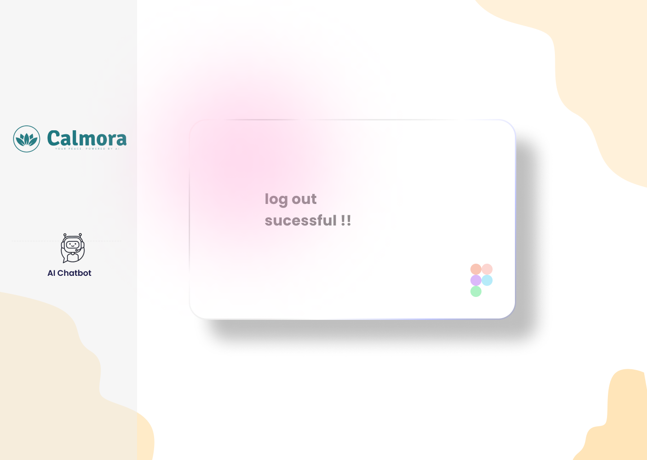

**Page Name: Logout Interface with Demo Bot**

**Elements on the Page:**

**Header Section:**

1. **Title**:
   * *"Are You Sure You Want to Log Out?"*

**Main Content Area:**

1. **User Prompt**:
   * **Message**:
     + Example: *"Hi, [User Name]! We’ll miss you, but you can log back in anytime."*
   * Reminder: *"Any unsaved progress will be lost."*
2. **Demo Chatbot**:
   * **Purpose**:
     + The chatbot remains active to assist users, even on the logout page.
   * **Capabilities**:
     + Provides navigation assistance, e.g., *"Would you like to stay logged in or explore our features as a guest?"*
     + Displays brief highlights of Calmora’s features.
     + Offers direct access to services such as:
       - *"Would you like to learn more about meditation or guided exercises?"*
   * **Interface**:
     + Chat window embedded at the bottom right corner.
     + Input Field: Placeholder text *"Type here for help..."*.
     + Suggestions: Quick reply buttons like:
       - *"Cancel Logout"*
       - *"What’s New?"*
3. **Confirmation Buttons**:
   * **Logout Button**:
     + Text: *"Yes, Log Me Out"*
     + Action: Ends the user session and redirects to the Login page.
   * **Cancel Button**:
     + Text: *"No, Take Me Back"*
     + Action: Redirects back to the previous active page (e.g., Dashboard).
4. **Optional Links**:
   * **Feedback Option**:
     + Text: *"Tell us why you’re logging out."*
     + Redirects to a short feedback form.

**Footer Section:**

* Branding:
  + Calmora logo with tagline: *"Your Peace, Powered by AI."*
* Quick Links:
  + Login | About | Contact Us.

**Content of the Page:**

* **Encouraging Text**:
  + Example: *"Taking a break? Remember to log back in for your personalized mental health support."*

**Data Flow:**

1. **Session Termination**:
   * Clicking *"Yes, Log Me Out"* clears the user session and cookies.
2. **User Redirection**:
   * Successfully logs the user out and redirects to the Login page.
3. **Demo Chatbot Interaction**:
   * User inputs are processed by the demo chatbot in real time.
   * Chat logs remain unsaved unless redirected to another service.
4. **Optional Feedback**:
   * Stores feedback in the database if the user opts to provide it.

**Control Flow:**

1. **Before Interaction**:
   * Displays a confirmation prompt with Logout and Cancel options.
   * Demo Chatbot is visible and ready to assist.
2. **During Interaction**:
   * User interacts with the chatbot for navigation or feature suggestions.
   * User clicks Logout or Cancel:
     + If Logout, the system clears the session and redirects to Login.
     + If Cancel, the system retains the session and navigates back to the previous page.
3. **After Interaction**:
   * Chatbot remains active until the user logs out completely.
   * Logs or session cookies are cleared on Logout.
   * Optional feedback is processed if submitted.

# Calmora project:

**1. Project Overview**

The project is a mental health platform called **Calmora**, designed to provide mental health support to users through the following features:

* **Key Features**:
  + Assessments
  + Recommendations
  + Progress Tracking
  + Mood Diaries
* **Interactive Component**: Uses a chatbot to engage users and recommend services based on their inputs.

**2. Technical Stack**

* **Repository**: GitHub
* **Database**: MySQL or SQL
* **Deployment**: Heroku (or any stack compatible with the website functionality)

**3. Feature List**

**Before Login Features:**

1. **Landing Page**:
   * Navigation Bar: Links to *Home, Services, About, Contact, Login/Signup*.
   * Demo Button: Redirects to the Chatbot.
   * *Find Out More* Button: Redirects to the Services Page.
2. **Chatbot (Demo Mode)**:
   * Analyzes basic user inputs and provides mock recommendations.
   * Guides users to sign up/login for full access to features.
3. **Services Page**:
   * Displays static information about available services.
   * Encourages users to sign up/login for detailed access.
4. **About Page**:
   * Provides information about Calmora and its features.
   * Interaction prompts redirect users to the Login/Signup page.
5. **Contact Page**:
   * Static page with a subscription feature.
   * Sends notifications like reminders to log in for daily assessments.
6. **Login/Signup Page**:
   * Handles standard authentication functionality.

**After Login Features:**

1. **Dashboard**:
   * Displays personalized mental health trends, mood logs, and real-time alerts.
   * Quick snapshot of the user’s mental health status.
2. **Mood Assessments**:
   * Tracks user mood and suggests tailored activities and recommendations.
   * Includes a Mood Diary for detailed user entries.
3. **Recommendations**:
   * AI-powered suggestions based on mood logs and wearables.
   * Quick actions like logging mood or starting relaxation exercises.
4. **Progress Reports**:
   * Provides graphical reports on mood trends, stress distribution, and activity logs.
   * Generates insights based on assessments.
5. **Music Therapy**:
   * Suggests playlists based on the user’s mood.
   * Includes interactive music recommendations for emotional well-being.
6. **Guided Workout Exercises**:
   * Features Yoga, Breathing Exercises, and Stretching routines.
   * Tracks achievements such as hours, calories burned, and sets completed.
7. **AI Chatbot (Post Login)**:
   * Offers direct access to services and personalized recommendations.
   * Assists users interactively with navigation and queries.
8. **Mood Diary**:
   * Analyzes user inputs for AI insights.
   * Tracks mood entries and suggests personalized activities.
9. **Download Reports**:
   * Enables users to download detailed progress reports.
10. **Settings Page**:
    * Edit Profile
    * Security & Privacy Settings
    * Add Accounts
    * Subscription Management
    * Terms & Policies
11. **Alerts & Notifications**:
    * Sends real-time alerts for high-stress detection.
    * Push notifications for reminders like daily assessments.

**4. Data Flow**

**Before Login:**

* **Landing Page**:
  + Navigation links redirect to respective pages.
  + The chatbot collects user inputs and temporarily stores session data to encourage sign-up/login.
* **Subscription Requests**:
  + Stores user email addresses for notifications.

**After Login:**

* **Dynamic Data Flow**:
  + **Mood Assessments**: Analyzes user inputs, stores data, and generates tailored recommendations.
  + **Mood Diary**: Stores user entries and processes data for insights.
  + **Recommendations**: Uses historical data (mood, logs, wearables) to suggest activities.
  + **Progress Reports**: Pulls data from the database to display trends and analytics.
  + **Music Therapy/Workout Exercises**: Fetches suggestions based on current mood and progress.
  + **AI Chatbot**: Accesses database data to recommend services and insights.
  + **Alerts/Notifications**: Dynamically generated based on real-time activity and thresholds.

**5. Control Flow**

**Before Login:**

* Users interact with static pages and the demo chatbot.
* All interactions encourage sign-up or login for full access.

**After Login:**

* User authentication provides access to dynamic features like the Dashboard, Recommendations, and AI Chatbot.
* Notifications and alerts trigger based on user activity, mood logs, and stress analysis.

**6. Developer Instructions**

**Implementation Requirements:**

1. Use GitHub for repository management.
2. Store all data in MySQL (or SQL as needed).
3. Deploy the application on Heroku.
4. Ensure clear navigation between pages while maintaining data integrity.

**Key Notes:**

1. Maintain a seamless user experience during transitions.
2. Use API endpoints for AI features like mood analysis and chatbot recommendations.
3. Ensure secure authentication and data storage.
4. Implement analytics for mood tracking and assessments.

**Particular Requirements:**

1. Ensure the chatbot can extend conversations dynamically and suggest services effectively.
2. Notifications must be user-specific and trigger based on real-time conditions (e.g., missed assessments).
3. Detailed insights and reports must be exportable/downloadable.